[1]

Computer Tools

Name of Teacher : Zohreh Moeini

Name of Student: Balraj Heer

Table of Content

IT SPECIALISTS AND THEIR JOB MARKET 2

QA Analyst 3

Job Market 4

Front-end developer 4

Job Market 5

Back-end developer 5

Job Market 6

[2]

# IT SPECIALISTS AND THEIR JOB MARKET

An IT specialist is any position that involves the implementation, support, maintenance, repair or protection of data or computer systems. Those involved in development, deployment or support of the systems or applications others use are the most common examples of IT jobs. If you like problem solving and being an active learner, a technology job could be right for you.

IT jobs run the gamut. Here’s a brief rundown of some IT job possibilities. Keep in mind that these positions can also be industry specific, so you could work one of the following roles in an industry of your choice.

Some of these are as follows:-

1. Front-end developer
2. Back-end developer
3. QA analyst
4. Database developer
5. Network Administration

[3]

#### *QA Analyst*

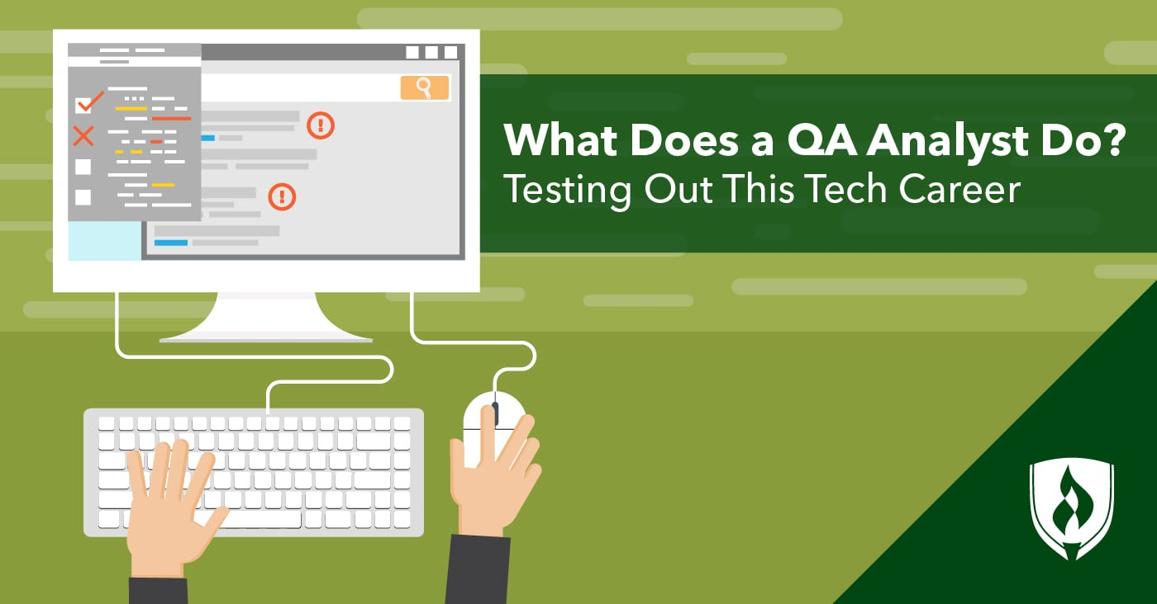

Quality assurance is a system of testing which guarantees that the customer is given high quality software that’s free of critical errors. QA testers dream of releasing a piece of software completely free of bugs, however, they are a fact of life in software development. Nam imperdiet mattis metus ac mollis. Sed non odio vehicula, iaculis tortor vitae, fringilla nibh. Maecenas ac elit id massa gravida tempor at et risus. Nulla ullamcorper pulvinar faucibus. Aliquam erat volutpat. Cras quis mi quis nisl ultricies mattis. Mauris gravida leo id leo aliquam, et malesuada nibh varius. Nullam luctus tortor lectus, nec fermentum sapien dictum quis. Donec varius felis at mollis ullamcorper. Quisque tempor ligula ac viverra imperdiet.

##### Job Market

Information systems specialists analyze, test and assess systems requirements, develop and implement information systems development plans, policies and procedures, and provide advice on a wide range of information systems issues. They are employed in information technology consulting firms and in information technology units throughout the public and private sectors, or they may be self-employed[4]

## Front-end developer

A Front-End Developer is someone who creates websites and web applications.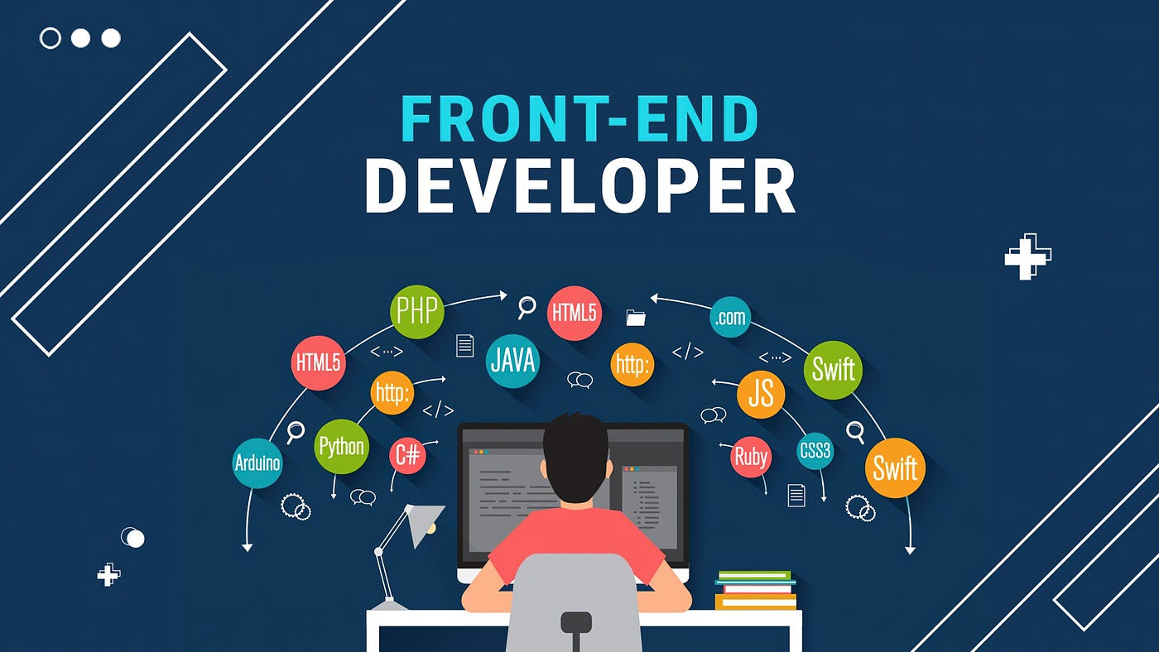 Etiam non ornare tortor. Proin neque tellus, rhoncus tincidunt imperdiet quis, vehicula eu lorem. Cras sollicitudin odio eu ipsum eleifend, ac suscipit ante semper. Quisque dolor ex, ornare nec pharetra cursus, euismod eget quam. Etiam sagittis diam ut nibh ullamcorper, sed pulvinar dui pretium. Donec rutrum efficitur vestibulum. Mauris sollicitudin ante ut mauris ultricies, sit amet sollicitudin nisl sollicitudin. Interdum et malesuada fames ac ante ipsum primis in faucibus. Ut nisl leo, cursus rutrum malesuada in, semper vitae ante. Donec tristique purus lorem, a efficitur ligula sodales et. Aliquam ornare mi neque, et scelerisque quam egestas id.

Website development process, without which a web page does not exist. Hypertext means that text has links, termed hyperlinks, embedded in it. When a user clicks on a word or a phrase that has a hyperlink, it will bring another web-page. A markup language indicates text can be turned into images, tables, links, and other representations. It is the HTML code that provides an overall framework of how the site will look. HTML was developed by [Tim Berners-Lee](https://en.wikipedia.org/wiki/Tim_Berners-Lee).

###### Job Market

For **Web designers and developers**[5], over the period 2022-2031, new job openings (arising from expansion demand and replacement demand) are expected to total **10,400** , while **12,700** new job seekers (arising from school leavers, immigration and mobility) are expected to be available to fill them.

As job openings and job seekers are projected to be at relatively similar levels over the 2022-2031 period, the balance between labour supply and demand.

### Back-end developer

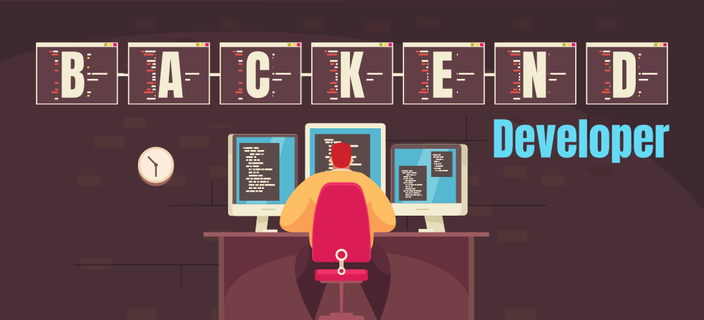

A back-end web developer is responsible for server-side web application logic and integration of the work front-end developers do. Back-end developers are usually write the web services and APIs used by front-end developers and mobile application developers. Etiam non ornare tortor. Proin neque tellus, rhoncus tincidunt imperdiet quis, vehicula eu lorem. Cras sollicitudin odio eu ipsum eleifend, ac suscipit ante semper. Quisque dolor ex, ornare nec pharetra cursus, euismod eget quam. Etiam sagittis diam ut nibh ullamcorper, sed pulvinar dui pretium. Donec rutrum efficitur vestibulum. Mauris sollicitudin

Job Market

Statistics from the [US Bureau of Labor and Statistics](https://www.bls.gov/ooh/computer-and-information-technology/web-developers.htm)[6] show that this profession will grow 13% by 2028, thanks to a rise in the popularity of mobile devices and the ecommerce industry.

With statistics like these in mind, it’s safe to say that backend developers have a bright career ahead of them. In other words, if you decide to pursue this career path, you’ll have no problem finding job opportunities.

1. IT specialist
2. IT specialist
3. IT specialist
4. IT specialist
5. IT specialist
6. IT specialist